**Introduction to software engineering: 0721110**

**Quiz 2**

1. What are the main components of an SRS document?

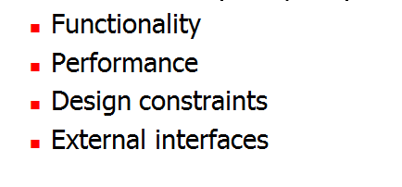

2. What are the main criteria for evaluating the quality of an SRS?

